LAB#3

Fundamentals of JavaScript

**OBJECTIVE:** Learn and Understand core JavaScript concepts.

# Student Task

**Task 1: Practice working with Date and Math objects.**

* A computer screen shot of a program code

  AI-generated content may be incorrect.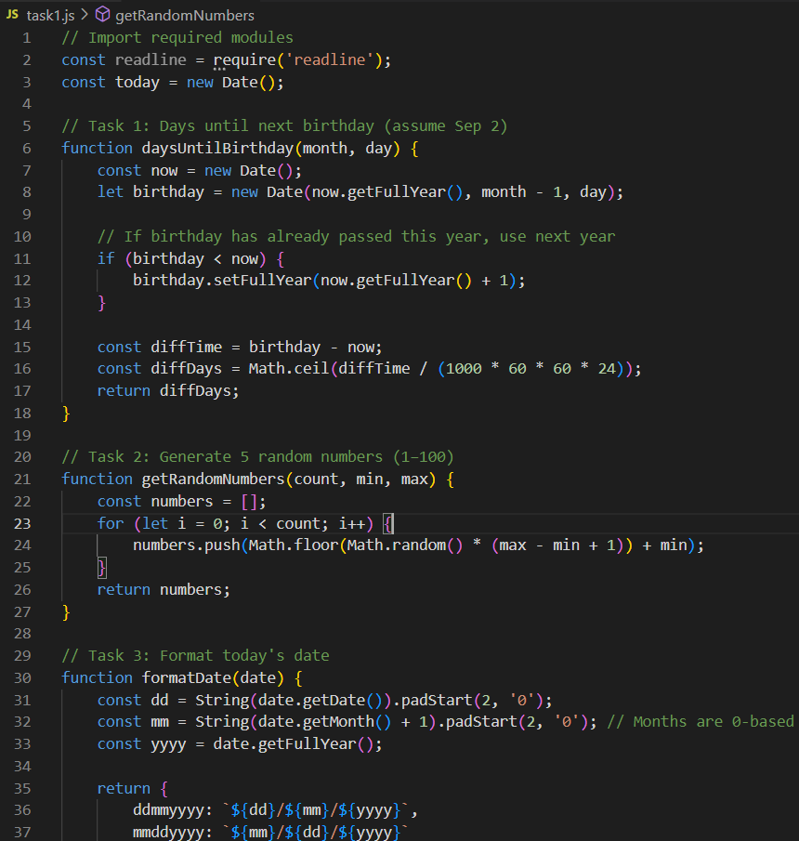**CODE**
* **OUTPUT**

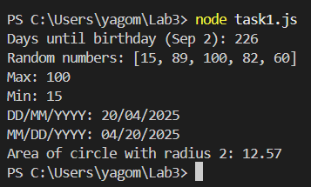

**Task 2: Practice advanced array methods.**

* **CODE**

* **OUTPUT**

**Task 3: Practice basic object operations with a shopping cart scenario.**

* A computer screen shot of a program

  AI-generated content may be incorrect.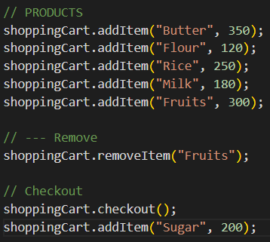**CODE**
* **OUTPUT**

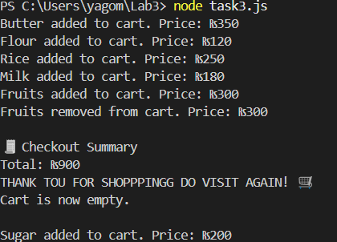

# Hands on Practice Task (Class Practice)

**Task 1: Practice variable declarations, data types, and basic operations.**

* **CODE**

* **OUTPUT**

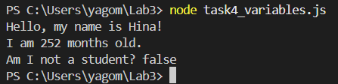

**Task 2: Practice working with arrays and array methods.**

* **CODE**

* **OUTPUT**

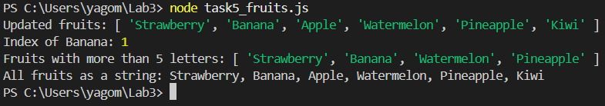

**Task 3: Practice creating and using functions.**

* **CODE**

* **OUTPUT**

**Task 4: Practice using conditional statements and loops.**

* **CODE**

* **OUTPUT**

